Data analyst Project2
Analyst: Aleke James
Date: June 28, 2026
Introduction
This report summarizes the exploratory analysis (EDA) done on data analysis dataset from DecodeLab. Following the cleaned dataset gotten from project1, this report summarizes dataset trends, and significant operational concerns. A significant correlation between high-value orders and cancellation rates, as well as certain product categories that affect revenue, are among the key results. Find the analysis below which was done using python libraries like pandas, seaborn and matplotlib. pyplot.
Step1: data loading
The cleaned data from project1 was loaded using pandas.
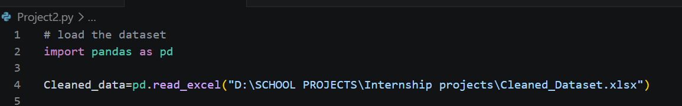
Step2: Basic statistics for numeric columns
This calculate mean, medians etc. that helps to understand the data
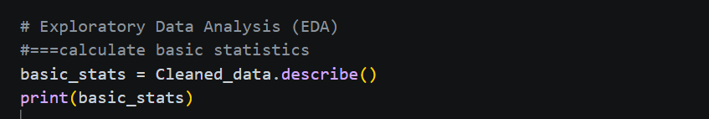
results
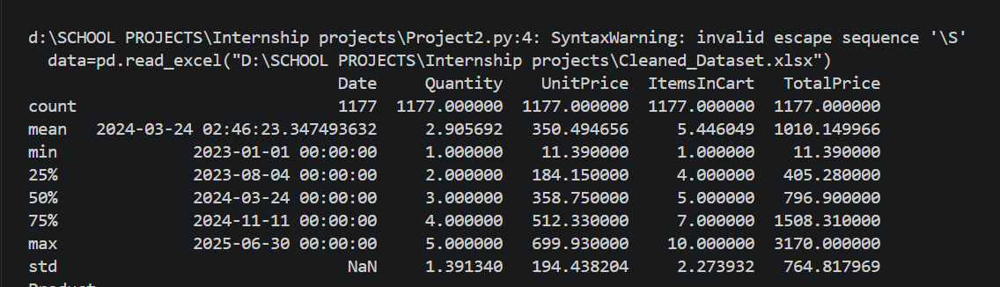
Step3: Outlier analysis
This process helps to compare the range of numeric values in the numeric columns. In this dataset high values were detected total price column and decided to retain them as they might represent significant transactions so removing them might affect total revenue.
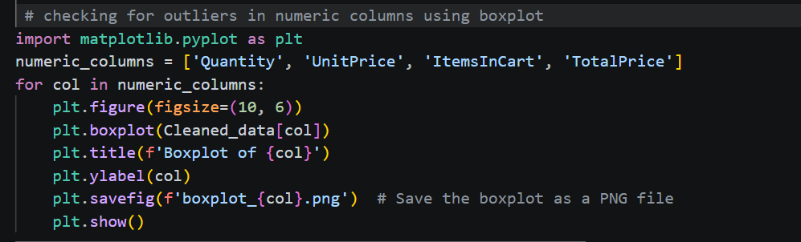
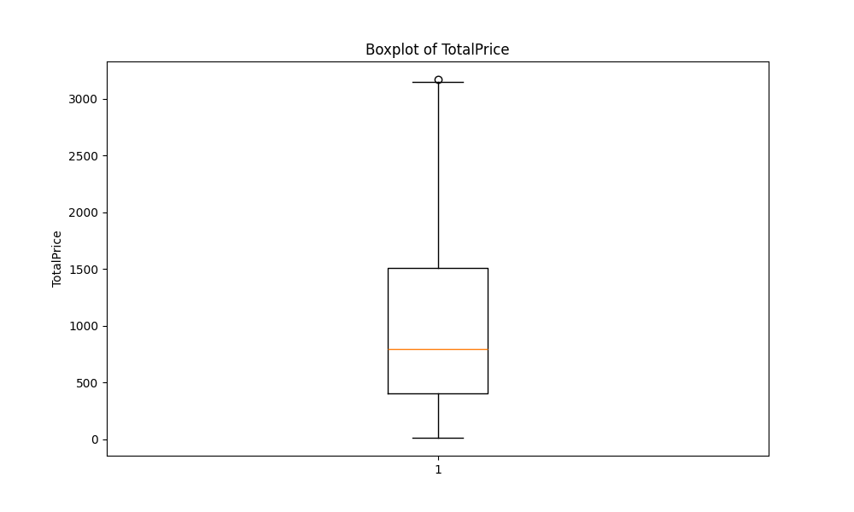

Step4: General analysis
Analyzed the products, the total revenue and checked some columns/ factors that affects revenue.
1.checked total item sold of each product category
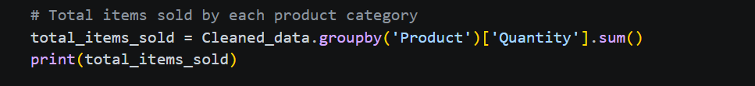
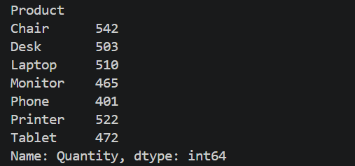

2. Checked total revenue generated by each product category
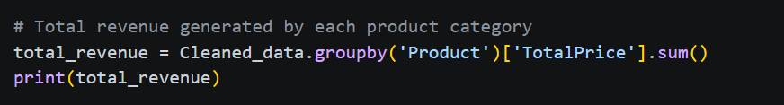
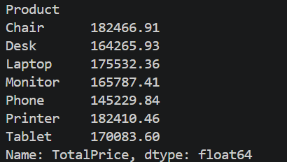
After checking that products which are many have higher revenue and didn’t see any problem, then went ahead with the analysis.

3. Checking if coupons influence the revenue and found out that free ship code has higher revenue than the other coupons which suggest that offering free shipping encourages/makes customers to add more items to their cart (increasing ItemsInCart or Quantity) to reach a threshold, ultimately driving higher revenue.
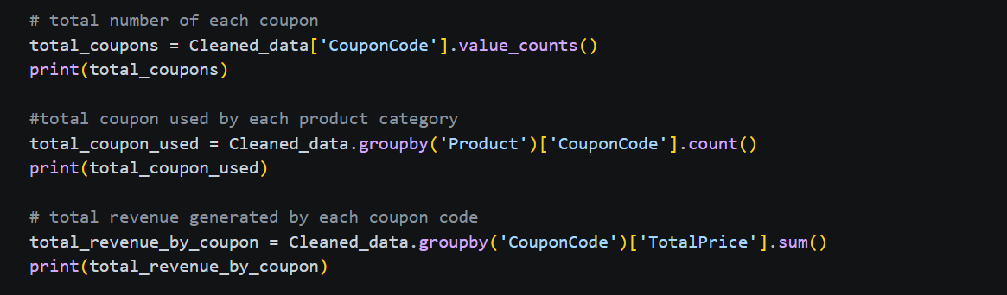
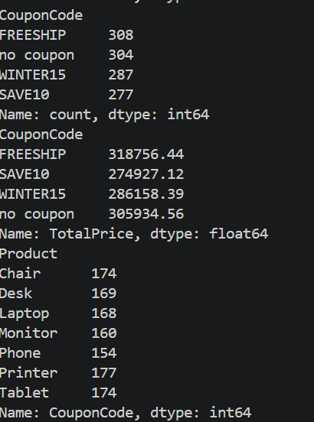

4. checked if order status influence revenue
Found out that the company is losing a lot of money as the number of returned and cancellation items is high especially in chairs and tablets ( 24% cancellation and return rate). This means that there might be quality issue with these items that makes customers return them and this is mostly happening to customers without coupons which suggest that they are not satisfied with the product because they paid full amount , they were also expecting good quality products. Therefore, the company should work on the quality of their products and investigate on how they can satisfy their customers.
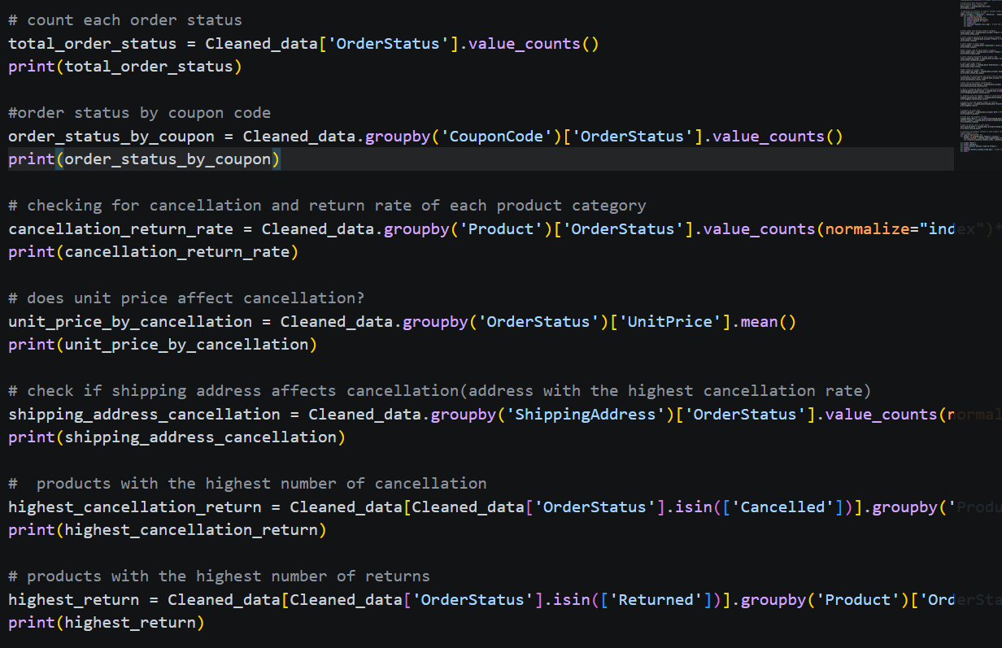

5. Checking the month with higher sales and revenue
The analysis shows that each product has its own peaking period e.g. Tablets have higher performance consistently in 4 months and chairs in June to July. Therefore, the company needs to consider these months and months with lower performance like September e.g. investing in markets to improve revenue.
